**Green House Monitoring & Control System**

**INTRODUCTION**

Green houses help to protect crops from many diseases, particularly those that are soil borne and splash onto plants in the rain. Greenhouse effect is a natural phenomenon and beneficial to human being. Numerous farmers fail to get good profits from the greenhouse crops for the reason that they can’t manage two essential factors, which determines plant growth as well as productivity. Green house temperature should not go below a certain degree, High humidity can result to crop transpiration, condensation of water vapour on various greenhouse surfaces, and water evaporation from the humid soil. To overcome such challenges, this greenhouse monitoring and control system

comes to rescue. This project demonstrates the design and implementation of a various sensors for greenhouse environment monitoring and controlling

**FEATURES:**

• User can know the temperature, humidity and soil moisture values in Web page or mobile App.

• User has an option of selecting particular crop from the mobile app so that the optimal conditions at the device will be configured according to the crop.

• If any parameters reach beyond the threshold values user is notified

with messages.

**SOFTWARE USED:**

1. Arduino IDE

2. IBM Cloud account

3. IBM IoT platform

4. NodeRed

5. MIT app inventor.

**HARDWARE USED:**

1.Nodemuc ESP8266

2.DHT11-to measure the temperatureand humidity

3.Sensor to measure Soil moisture

**BLOCKDIAGRAM:**

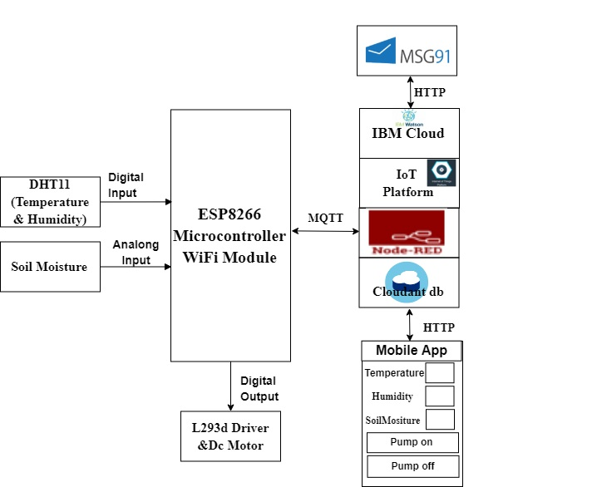

**ADVANTAGES :**

• You can control levels of carbon dioxide, light, and temperature, as well as mineral

content.

• High profits.

• Clean and large crops.

• Crops can grow in poor areas.

• No ploughing , less staff

**DISADVANTAGES:**

• Expensive.

• Lots of planning needed.

• Electricity &amp; gas needed to maintain it.

• Alarms needed.

• Expensive to monitor.

• Income and ability to grow crops need to be balanced against the cost of the system.

**APPLICATIONS:**

1.Greenhouse and cool chain monitoring

2.Advance monitoring system

**CONCLUSIONS:**

In green house technology, more number of the parameters is to be control because,the

varieties of the crop are large. They are increasing day by day because of the development in agriculture technology. In this situation, the wireless sensor network with additional hardware and software is an efficient solution for green house control.

This advancement in precision agriculture through Wireless Sensor Network in green house control is extremely useful. This has scope in developing countries in globe, where agriculture is the main business.

**REFERENCE:**

• www.researchgate.com

• Leeexplore.ieee.org